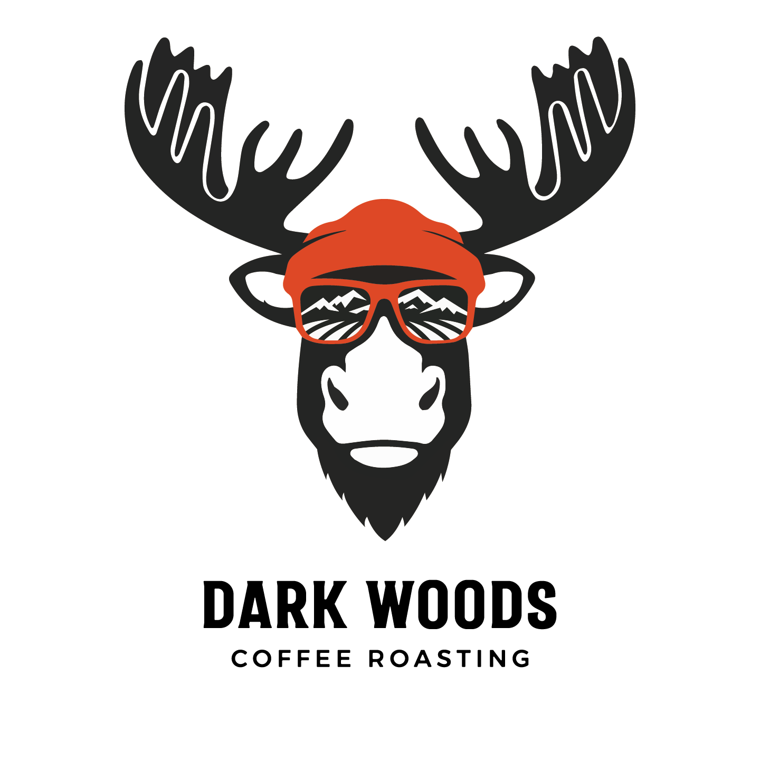

Dark Woods Coffee Fundraiser Order Form

Customer Info
Name: ___________________________
Phone: __________________________
Email: ____

Coffee
Coffee | Description
Traveler | Crafted for the road ahead, Traveler is a smooth yet bold medium roast designed to go wherever adventure calls. Rich, comforting notes of dark chocolate and warm cinnamon
Ski Bum | Built for first chair mornings and long days on the hill, Ski Bum is a bold, high-energy coffee designed to keep you warm from the inside out. This expertly roasted blend delivers a rich, satisfying cup with deep flavour and a smooth finish — perfect for cold starts and mountain air.
Camper | Built for early mornings, late nights, and everything in between, Camper is Dark Woods Coffee’s signature house blend.
Fisherman | You’ll find inviting notes of caramel and honey, layered with bright citrus and subtle tropical fruit, all wrapped in a smooth, clean finish. Carefully roasted to highlight balance and clarity,
Mountaineer-Espresso Blend | Climb higher with every cup. Mountaineer is a bold, rich espresso blend crafted for those who demand depth, balance, and a powerful flavour profile that holds up through milk-based drinks and straight shots alike.
Star Gazer - Decaf - Organic | Enjoy rich coffee flavour without the caffeine compromise. Our Organic Decaf Coffee is carefully decaffeinated using the Swiss Water Process, a gentle, chemical-free method that preserves the natural sweetness and character of the beans  All the flavour, None of the Caffeine

340g Bags
Coffee 340g Bags | Ground-Qty | Whole  Bean-Qty | Total  Qty | Price Per bag | Total
Traveler |  |  |  | $17
Ski Bum |  |  |  | $17
Camper |  |  |  | $17
Fisherman |  |  |  | $18
Mountaineer |  |  |  | $19.75
Star Gazer-Decaf- |  |  |  | $19
340g Subtotal: $_________

1Kg Bags
Coffee 1Kg Bags | Ground-Qty | Whole  Bean-Qty | Total  Qty | Price Per bag | Total
Traveler |  |  |  | $48
Ski Bum |  |  |  | $48
Camper |  |  |  | $48
Fisherman |  |  |  | $50
Mountaineer |  |  |  | $55
Star Gazer-Decaf |  |  |  | $52

1Kg Subtotal: $_________

💳 Gift Cards
Value | Qty |  | Total
$25 |  | ___ | ___
$50 |  | ___ | ___
$75 |  | ___ | ___
$100 |  | ___ | ___
Gift Card Subtotal: $_________

✅ Grand Total
TOTAL ORDER: $_______________

Questions?
📧 Nick@darkwoodsbrewing.com

